Sequential Workflows in LangGraph
CampusX • Agentic AI using LangGraph • Video 5
Duration: 49:13
Video: https://www.youtube.com/watch?v=bAWujyAl1Kk
Practice repository: https://github.com/campusx-official/langgraph-tutorials

Learning outcomes
By the end, you should be able to create a StateGraph, explain the difference between state and a node’s partial update, build a deterministic pipeline, use model calls inside nodes, and recognize when prompt chaining is useful.
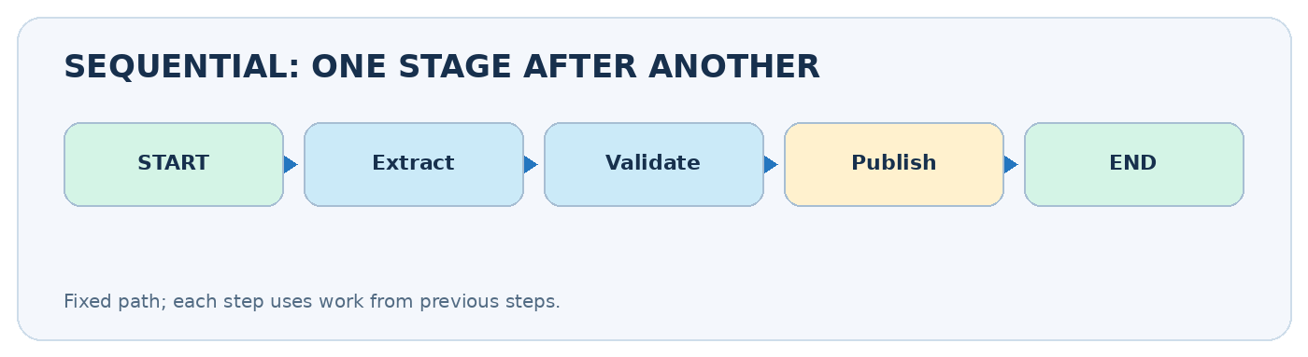
Sequential workflow: one stage after the next

Video chapter bookmarks
- 00:00 — Introduction
- 02:43 — Installation
- 07:17 — First workflow
- 26:11 — LLM workflow
- 36:55 — Prompt chaining
- 49:03 — Outro

1. What is a sequential workflow?
A sequential workflow is an ordered set of tasks where the next task starts after the previous one produces its result. Think START -> A -> B -> C -> END. For example, a blog-writing assistant might choose a topic -> create an outline -> write a draft -> proofread. The overall route is predetermined even if individual steps call an LLM.
- Predictable control flow: all runs normally follow the same node order.
- Shared state: earlier results are available to later nodes, rather than having to pass a long string between functions.
- Small, testable nodes: when output is wrong, inspect the node that introduced the error.
- Trade-off: dependent calls add latency; three sequential LLM calls often take longer than one call.
A sequential workflow is not necessarily an autonomous agent. It follows paths explicitly defined by the developer.

An everyday analogy
Imagine three people preparing a report. The researcher gathers facts; the writer makes a draft using those facts; the editor checks the draft. The next person waits for the previous person’s work. Their shared notebook is graph state.

2. Five core building blocks
Concept | Role | Example
TypedDict state | Describes keys shared by nodes | title, outline, article
Node function | Does work and returns updates | return {"outline": "..."}
START and END | Entry and exit markers | START -> outline -> END
add_edge() | Connects fixed transitions | add_edge("outline", "write")
compile() / invoke() | Builds and runs the graph | graph.invoke({"title": "AI"})
Important distinction: a state schema names possible fields; it does not require every output field to exist in the input dictionary. Prefer NotRequired where keys are intentionally created later. A node should usually return only changed keys, not copy and re-return everything.

3. Install and prepare an environment
python -m venv .venv
# Ubuntu / macOS:
source .venv/bin/activate
# Windows PowerShell:
# .\.venv\Scripts\Activate.ps1
python -m pip install -U langgraph langchain langchain-openai python-dotenv
Install ipykernel if working in Jupyter. The first practical example below uses no API key, so you can practice the graph mechanics without paying for model calls.

4. First practical workflow: calculate and label BMI
This exercise is intentionally ordinary Python. It isolates graph behavior from model behavior. Node 1 computes BMI, node 2 labels it, and both share the same BMIState.
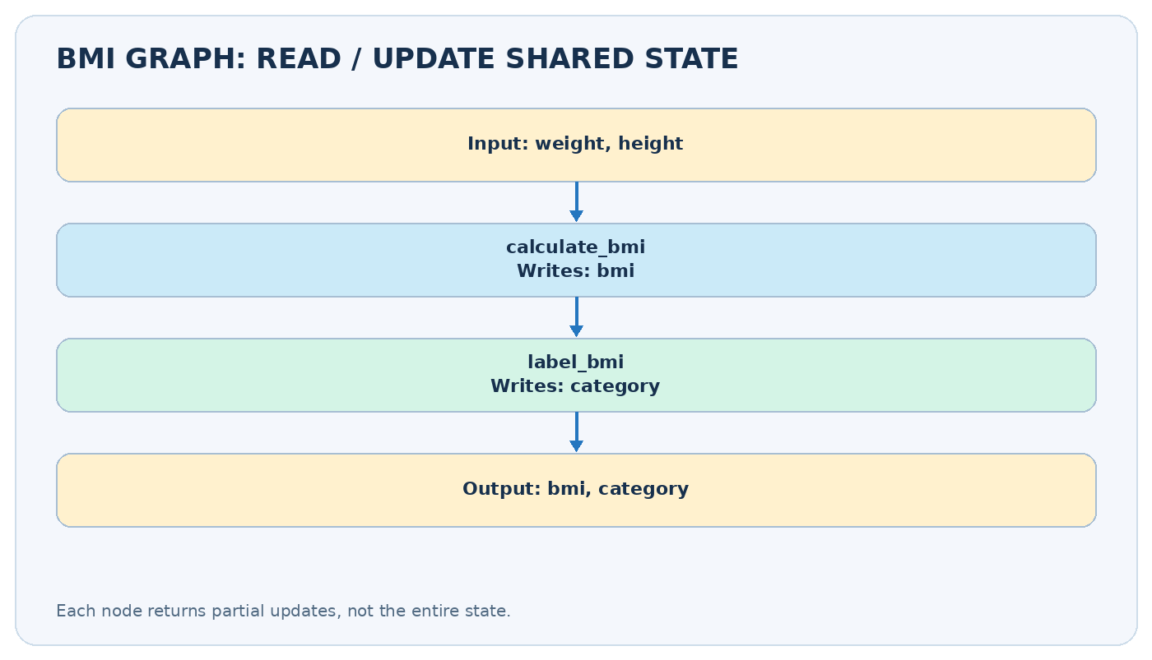
BMI example: what each node reads and writes
from typing import TypedDict, NotRequired
from langgraph.graph import StateGraph, START, END
class BMIState(TypedDict):
weight_kg: float
height_m: float
bmi: NotRequired[float]
category: NotRequired[str]
def calculate_bmi(state: BMIState) -> dict:
height = state["height_m"]
if height <= 0:
raise ValueError("Height must be positive")
return {"bmi": round(state["weight_kg"] / height**2, 2)}
def label_bmi(state: BMIState) -> dict:
bmi = state["bmi"]
if bmi < 18.5:
label = "Underweight"
elif bmi < 25:
label = "Normal"
elif bmi < 30:
label = "Overweight"
else:
label = "Obesity"
return {"category": label}
builder = StateGraph(BMIState)
builder.add_node("calculate_bmi", calculate_bmi)
builder.add_node("label_bmi", label_bmi)
builder.add_edge(START, "calculate_bmi")
builder.add_edge("calculate_bmi", "label_bmi")
builder.add_edge("label_bmi", END)
app = builder.compile()
result = app.invoke({"weight_kg": 80.0, "height_m": 1.73})
print(result) # bmi approximately 26.73; category = 'Overweight'
The labels here demonstrate control flow, not individualized health advice.

Follow the state by hand
Moment | Keys known after the step
Input | weight_kg=80, height_m=1.73
After calculate_bmi | inputs preserved; bmi=26.73 added
After label_bmi | earlier keys preserved; category='Overweight' added
State accumulates partial updates
State accumulates partial updates
Why partial returns? If calculate_bmi returns {"bmi": 26.73}, the runtime merges that into the state. It is not necessary to return weight_kg or height_m again. This matters especially when you later learn parallel graphs, where two nodes writing the same unprotected key in one step can conflict.

5. Move from pure Python to an LLM node
LangGraph manages when nodes run; a model wrapper such as ChatOpenAI provides what an LLM node computes. Keep credentials out of source code. With an OPENAI_API_KEY set in your environment, a basic question-answering node could look like this:
from langchain_openai import ChatOpenAI
model = ChatOpenAI(model="gpt-4o-mini", temperature=0)
class QAState(TypedDict):
question: str
answer: NotRequired[str]
def answer_question(state: QAState) -> dict:
reply = model.invoke(f"Answer briefly: {state['question']}")
return {"answer": reply.content}
You would register answer_question exactly as you registered calculate_bmi. The graph does not care whether a node performs math, queries a database, invokes a tool, or calls a model. Do not call model.invoke unless your model and credentials are configured.

6. Prompt chaining: outline -> draft -> review
Prompt chaining means breaking one complex request into narrower, ordered model tasks. In a blog generator, the writer depends on the planner’s outline, and the editor depends on the draft.
class BlogState(TypedDict):
topic: str
outline: NotRequired[str]
draft: NotRequired[str]
final: NotRequired[str]
def plan(state: BlogState) -> dict:
response = model.invoke(f"Create a concise outline for: {state['topic']}")
return {"outline": response.content}
def write(state: BlogState) -> dict:
response = model.invoke(
f"Write a clear article on {state['topic']} using:\n{state['outline']}"
)
return {"draft": response.content}
def edit(state: BlogState) -> dict:
response = model.invoke(
f"Improve clarity and remove repetition:\n{state['draft']}"
)
return {"final": response.content}
blog = StateGraph(BlogState)
blog.add_node("plan", plan)
blog.add_node("write", write)
blog.add_node("edit", edit)
blog.add_edge(START, "plan")
blog.add_edge("plan", "write")
blog.add_edge("write", "edit")
blog.add_edge("edit", END)
blog_app = blog.compile()
# blog_app.invoke({"topic": "Vector databases"})
The benefit is not automatic output quality; it is task decomposition and observability. The editor can still miss factual errors. Add validation or human review when correctness matters.

7. Common mistakes and how to debug
Symptom | Likely cause | Fix
KeyError: 'outline' | Writer ran without an outline | Verify edge order; add input checks
Graph returns too early | Missing edge to a later node | Connect every stage to the next
Repeated or lost data | A node reassigns unrelated state | Return partial updates
LLM request fails | Missing API key / unavailable model | Verify environment and model access
Can’t see intermediate results | Only final invoke() output examined | Stream updates from the graph
To inspect which node changed what, use:
for event in app.stream({"weight_kg": 80, "height_m": 1.73}, stream_mode="updates"):
print(event)

8. When to choose this pattern
Choose sequential execution when later steps truly depend on earlier outputs: extract -> normalize -> validate, research -> summarize -> edit, or generate -> review -> publish. Avoid it when tasks are independent and could run concurrently: e.g., independently evaluating spelling, tone, and factuality. That is the topic of Video 6.

Quick self-check
- What would change if label_bmi ran before calculate_bmi?
- Why does the calculate_bmi node return only the bmi key?
- Which data should a blog writer read from shared state?
- What makes this workflow deterministic even when an LLM is called?

Practice task
Build an order-price calculator: subtotal -> apply_discount -> add_tax -> produce_receipt. Start without an LLM. Then add a text-generation node that explains the invoice. Check that the numeric result is calculated by Python, not guessed by the model.

9. Revision sheet
- ☐ I can explain START, END, nodes, and edges.
- ☐ I can build and compile a sequential StateGraph.
- ☐ I know a node returns a partial state update.
- ☐ I can trace values through three steps.
- ☐ I can place an LLM call inside one node.
- ☐ I can explain the costs and benefits of prompt chaining.
Next lesson: Parallel Workflows — independent tasks run concurrently and state updates must be merged safely.

Further reading
- Official LangGraph Graph API: https://docs.langchain.com/oss/python/langgraph/graph-api
- Official LangGraph introduction: https://docs.langchain.com/oss/python/langgraph/overview

